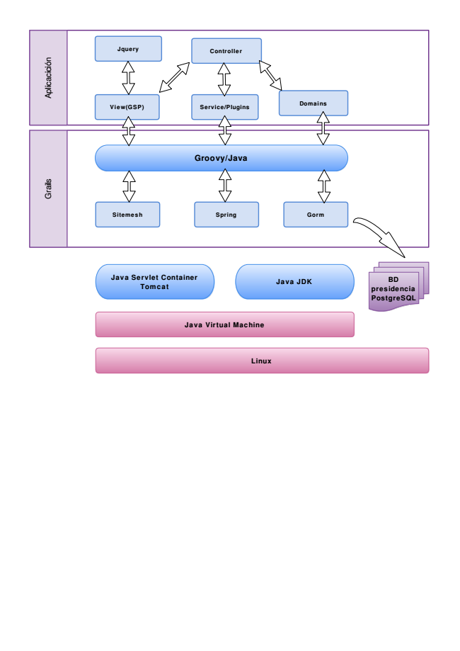

**Jquery**

**Controller**

**View(GSP)**

**Service/Plugins**

**Domains**

**Java Servlet Container Tomcat**

**Groovy/Java**

**Sitemesh Spring Gorm**

**Java Virtual Machine**

**Linux**

**Java JDK**

**BD presidencia PostgreSQL**